Student’s name | …………………………………………………….…… | Grade | 1
Subject | Computer | Week No. | 5
Lesson Title | My Desktop | Unit
Worksheet No. ( 5 ) (Answer)

Question A: write the correct name of each part

Apps | Files | Folders
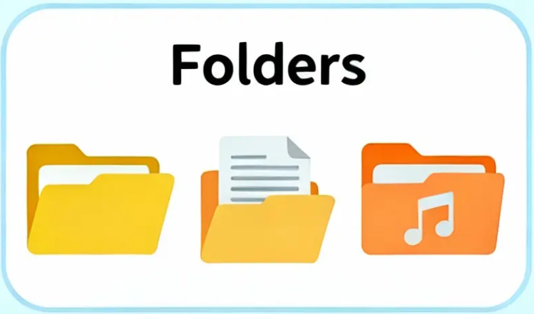

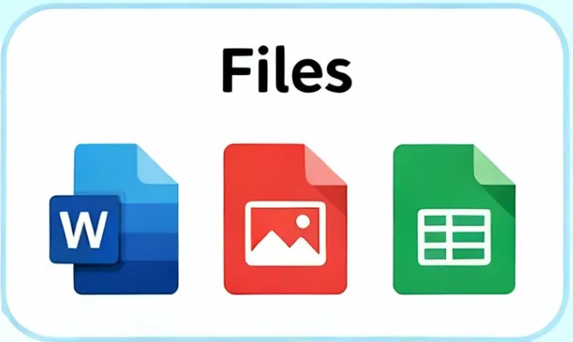
Files
Apps
Folders
Good Luck

